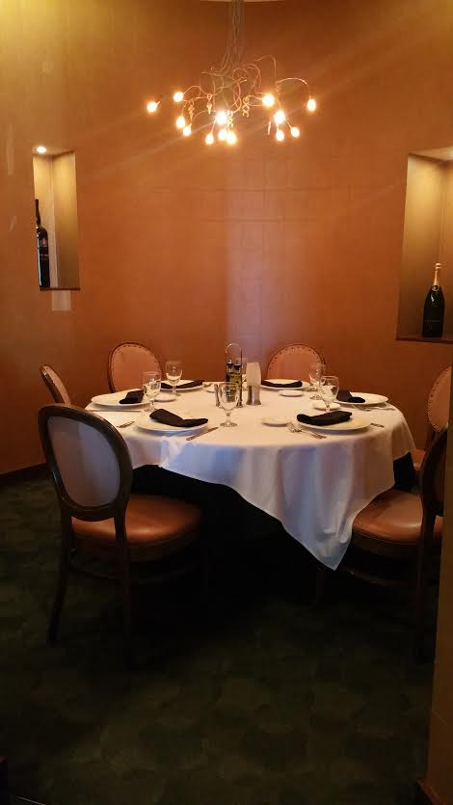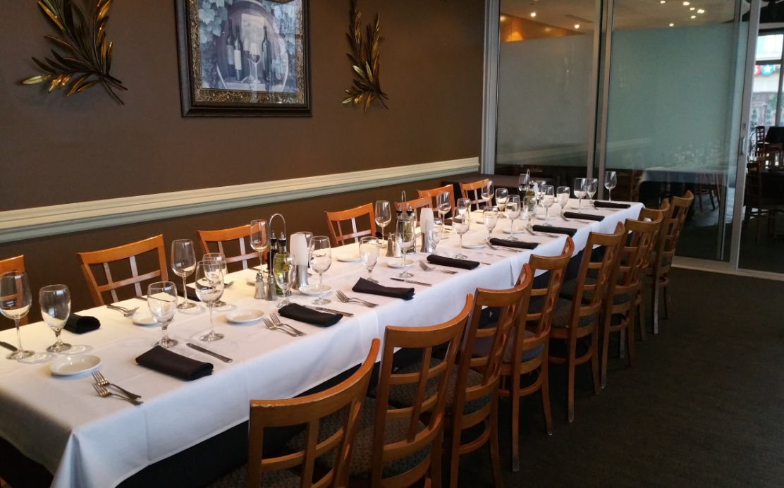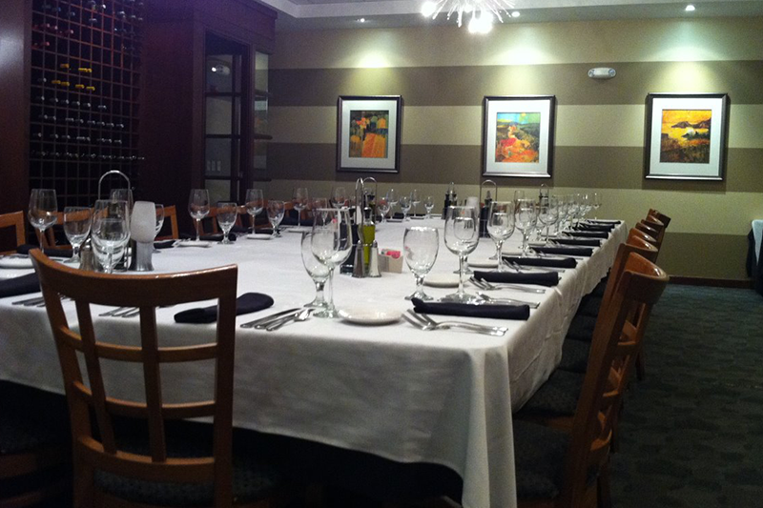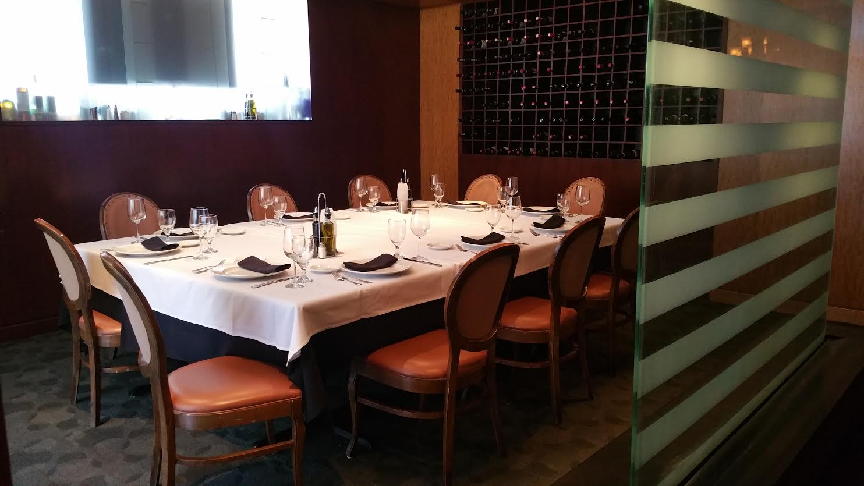

Seats up to 60 guests

Seats up to 18 guests

The Waterfall Room

The Riviera Room

Seats up to 26 guests

The Bellagio Room

Seats up to 10 guests

Private Alcove